Mini project exercise for Mongo DB lab

**BASIC SECTION** : How to Use AND Operator in MongoDB

**Dataset:**

Dataset - StudentsDetails2

{

"_id" : 1,

"std_name" : "Mukesh",

"Gender" : "Male",

"class" : "VI",

"age" : 11,

"grd_point" : 33

}

{

"_id" : 2,

"std_name" : "Dechamma",

"Gender" : "Female",

"class" : "VI",

"age" : 13,

"grd_point" : 30

}

{

"_id" : 3,

"std_name" : "Akash",

"Gender" : "Male",

"class" : "V",

"age" : 14,

"grd_point" : 35.1257

}

{

"_id" : 4,

"std_name" : "Geetha",

"Gender" : "Female",

"class" : "X",

"age" : 17,

"grd_point" : 36.2514

}

{

"_id" : 5,

"std_name" : "Bhomika",

"Gender" : "Female",

"class" : "X",

"age" : 19,

"grd_point" : 35.5201

}

{

"_id" : 6,

"std_name" : "Nitin",

"Gender" : "Male", "class" : "V",

"age" : 16,

"grd_point" : 35.5201

}

1. **Demonstrate Use Of And Operator Displays Record Whose Gender Is Female And Are Studing In X STD --2 Conditions --Use Add Condition.**

db.studentdetails.find({$and: [{ Gender: "Female" },{ class: "X" }]})

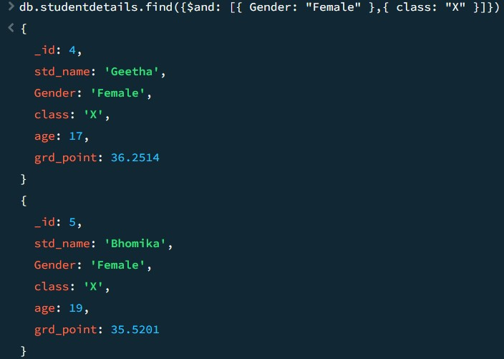

1. **Displays Count Regarding How Many Female Students Are There In X Std, Use Add Condition** db.studentdetails.countDocuments({$and:[{Gender:"Female" },{class: "X" }]})



1. **Demonstrate AND Operator Displays Record Whose Gender Is Male And Are In X STD** db.studentdetails.find({$and:[{Gender:"Male" },{class: "X"}]})



1. **Displays Count Regarding How Many Male Students Are There In V Std, Use Add Condition** db.studentdetails.countDocuments({

$and: [

{ Gender: "Male" },

{ class: "V" }

]

})

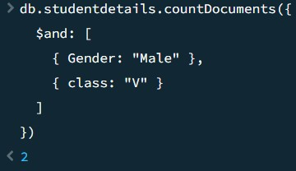

1. **Query To Find Whose Gender Male",grd_point>=19 And Class=X** db.studentdetails.find({

$and: [

{ Gender: "Male" },

{ grd_point: { $gte: 19 } },

{ class: "X" }

]

})

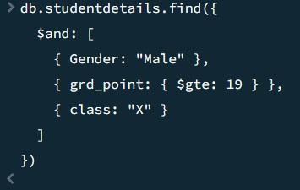

1. **Displays Students Details Whose Gender Is Female and grade point Greater Than Or Equal To 36 Use Add Condition.**

db.studentdetails.find({

$and: [

{ Gender: "Female" },

{ grd_point: { $gte: 36 } }

]

})

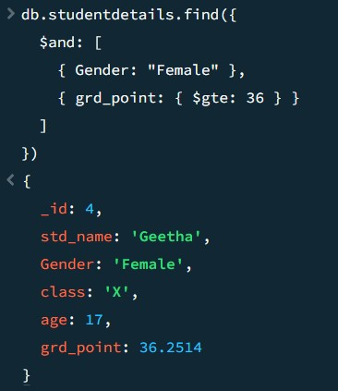

1. **Displays Students Details Whose grd_point between 30 and 35, Use Add Condition** db.studentdetails.find({

$and: [

{ grd_point: { $gte: 30 } },

{ grd_point: { $lte: 35 } }

]

})

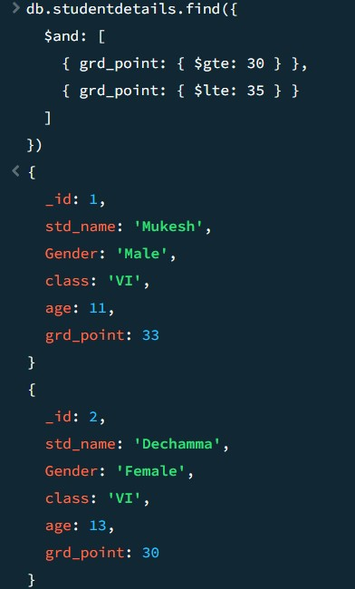

1. **Displays Students Details Whose Age Between 20 And 128** db.studentdetails.find({ $and: [

{ age: { $gte: 20 } },

{ age: { $lte: 128 } }

]

})

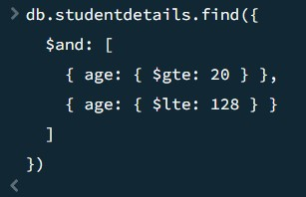

**INTERMEDIATE SECTION :**

Dataset

"_id" : 1,

"name" : "Prithvi",

favorites: [ "chocolate", "cake", "butter", "apples" ] ,

{ "_id" : 2,

"name" : "Shivakumar",

favorites: [ "apples", "pudding", "pie" ]

{ "_id" : 3, "name" :

"Pradeep",

favorites: [ "pears", "pecans", "chocolate", "cherries" ]

{ "_id" : 4,

"name" : "Mukesh",

favorites: [ "ice cream" ]

1. **Query Find Marks Greater Than Or Equal To 80 Using $Elemmatch** db.details.find({marks:{$elemMatch: { $gte:80 }}});

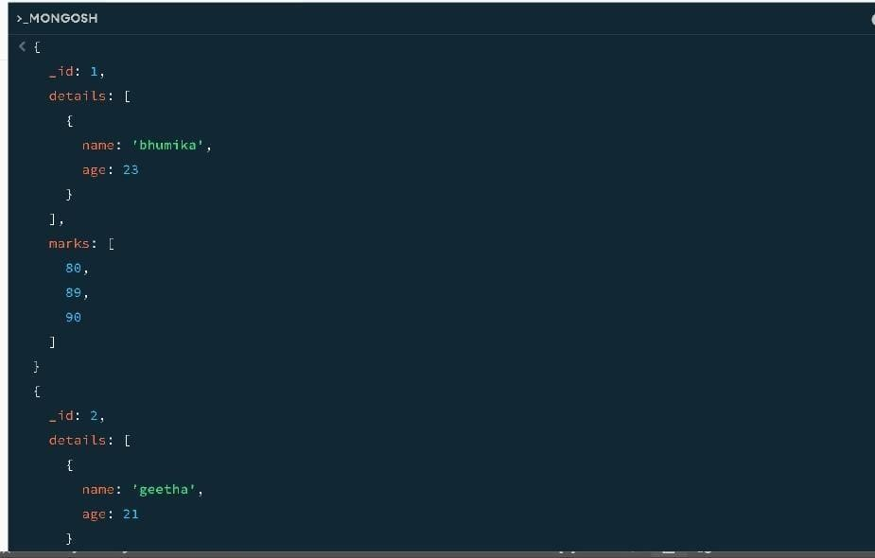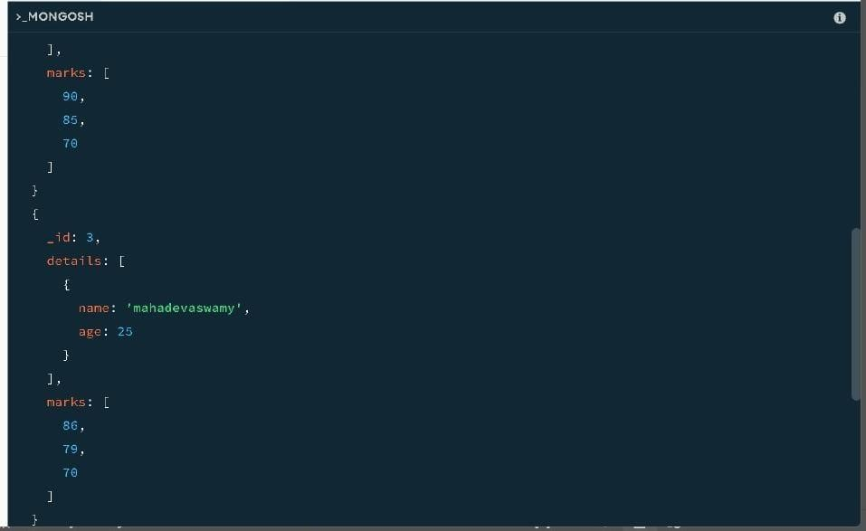

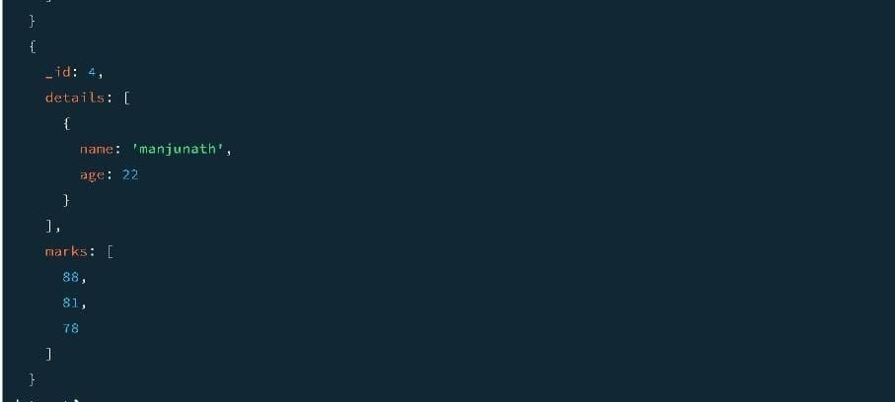

1. **Query To Find Marks Between 80 And 85 Using $Elemmatch** db.details.find({marks:{$elemMatch: { $gte:80,$lte:85 }}});

